**BI 1**

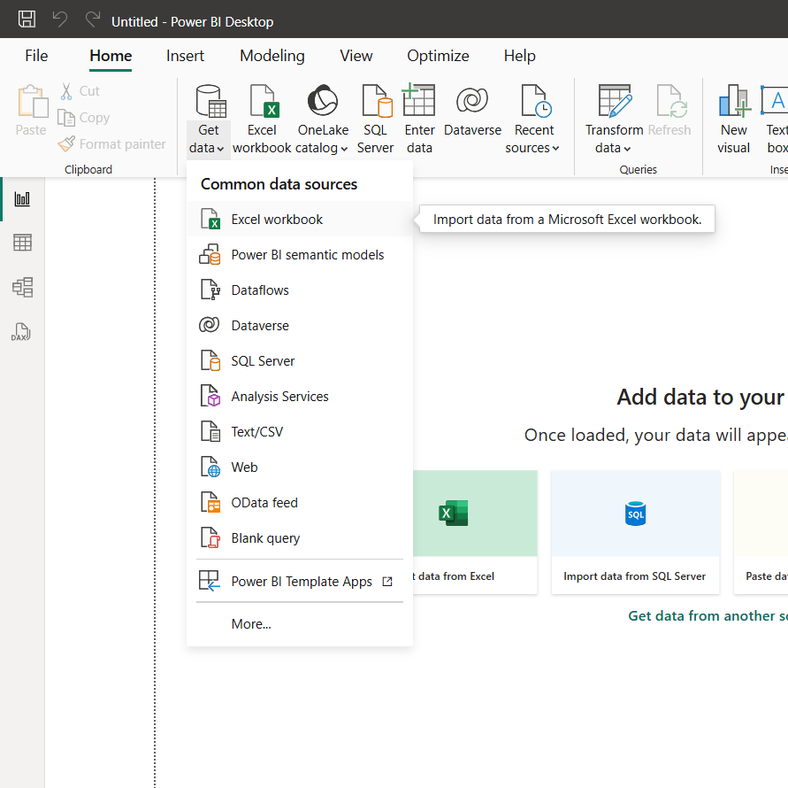

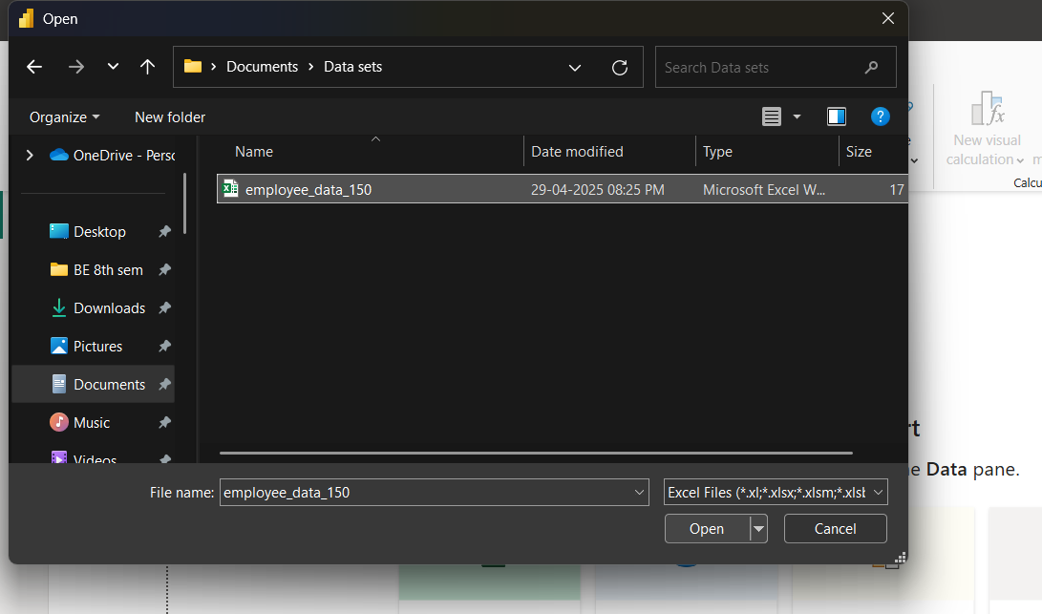

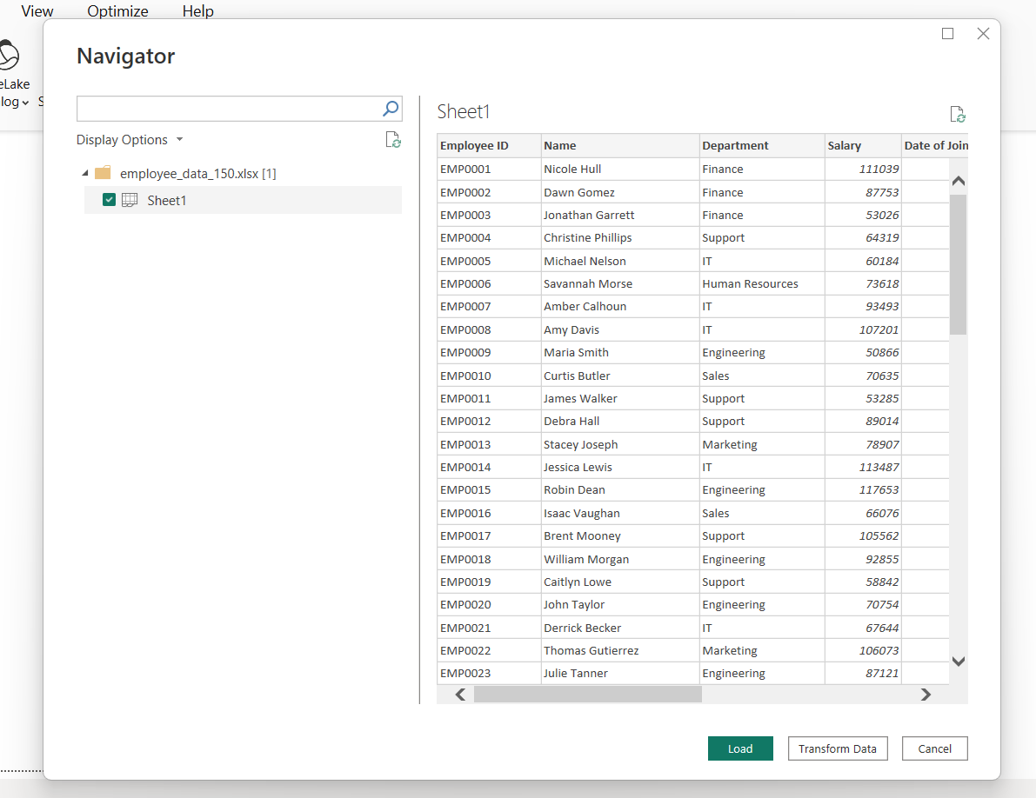

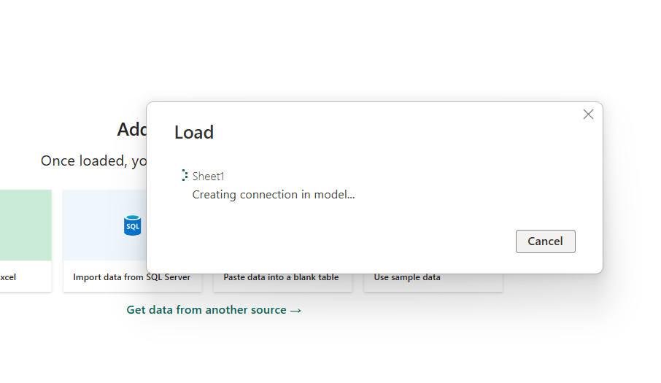

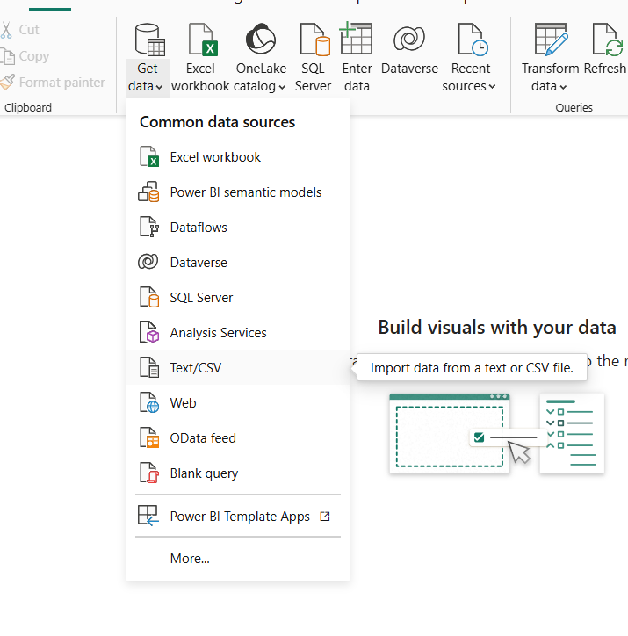

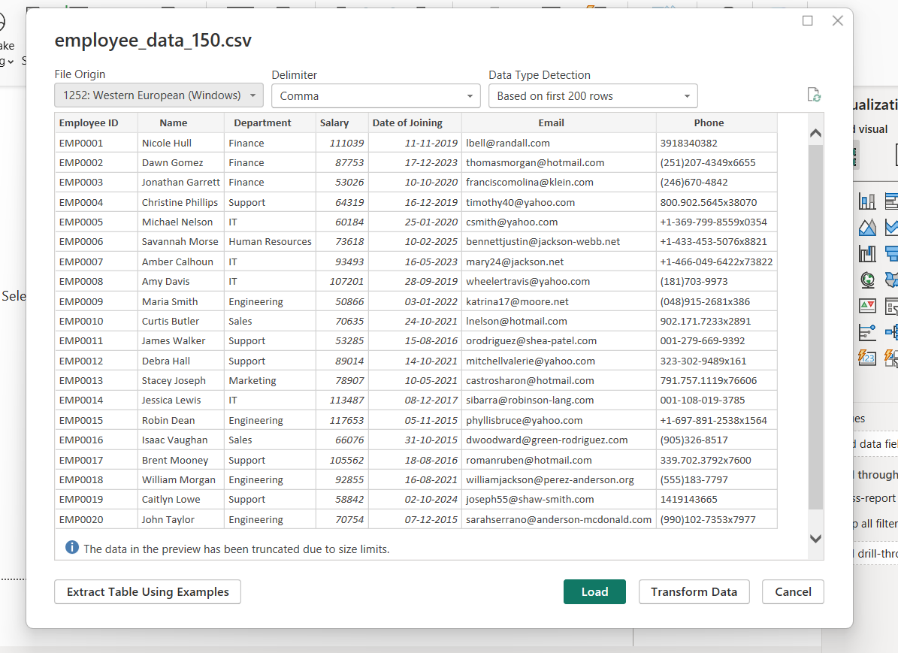

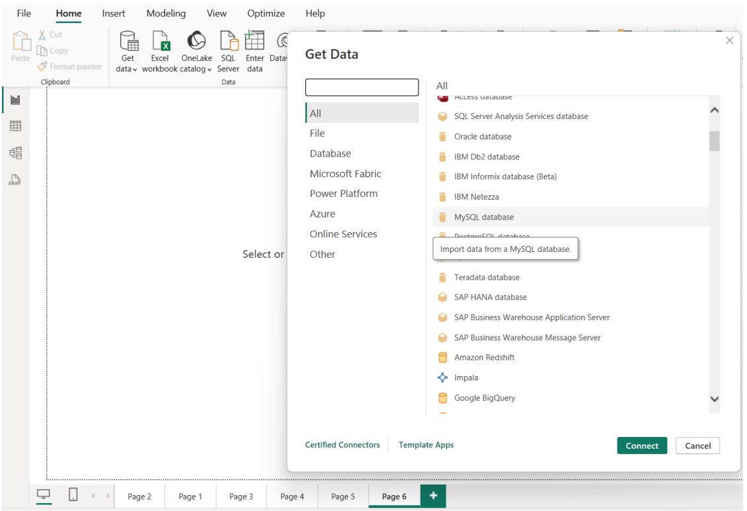

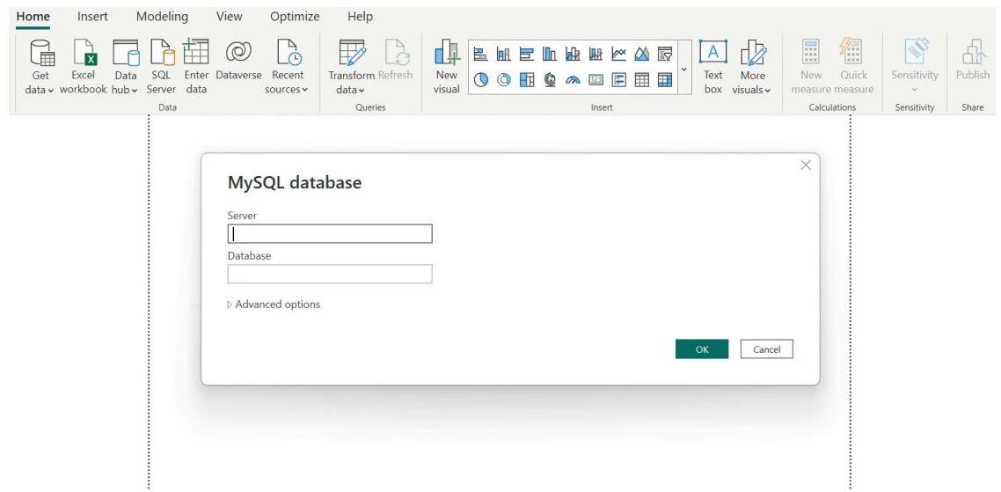

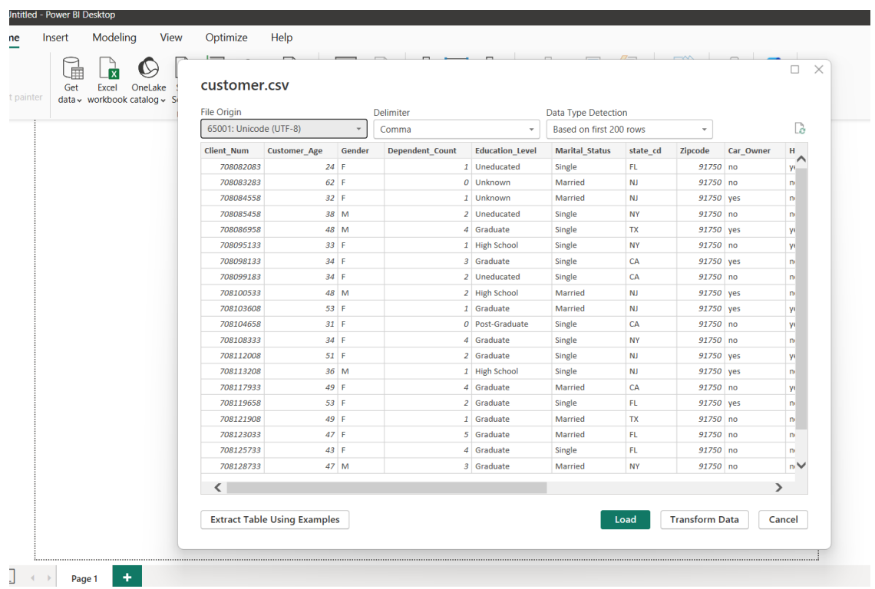

**BI 2**

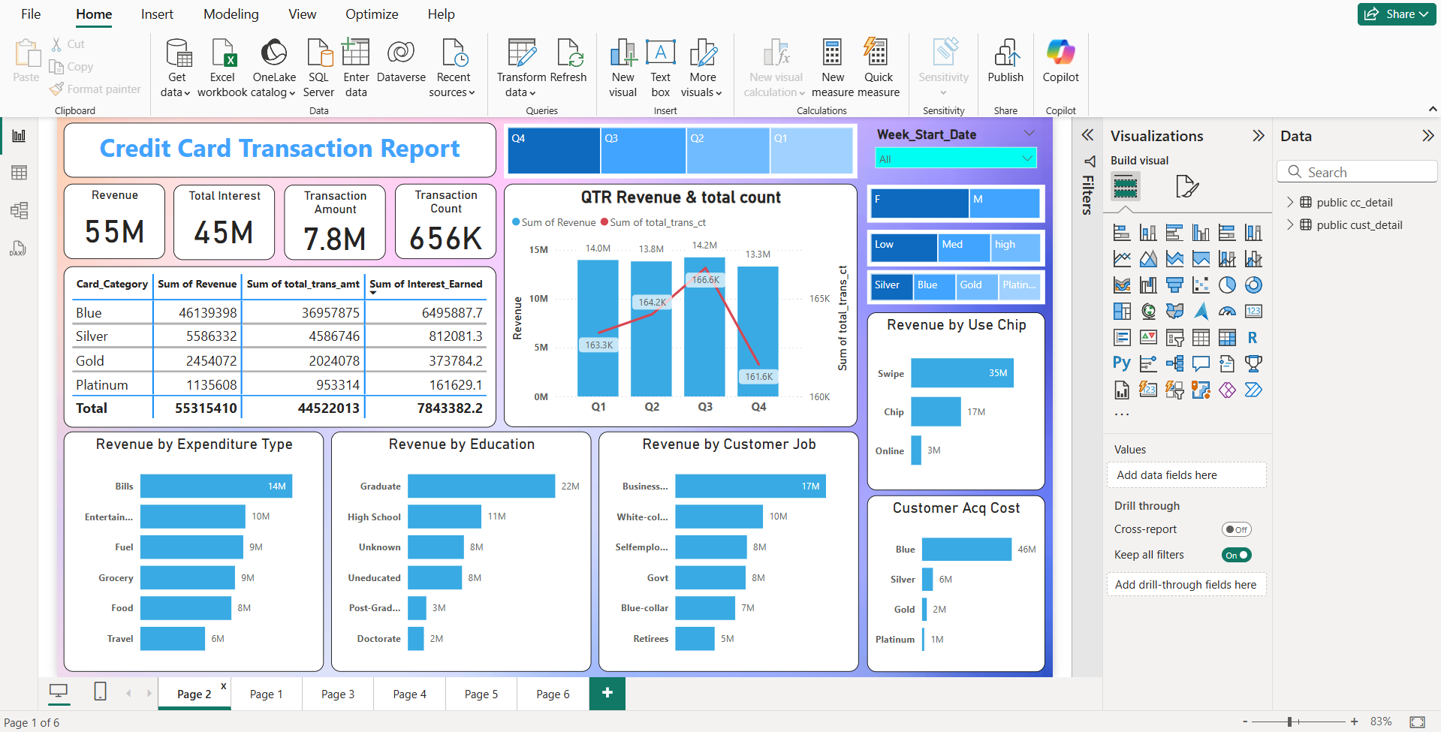

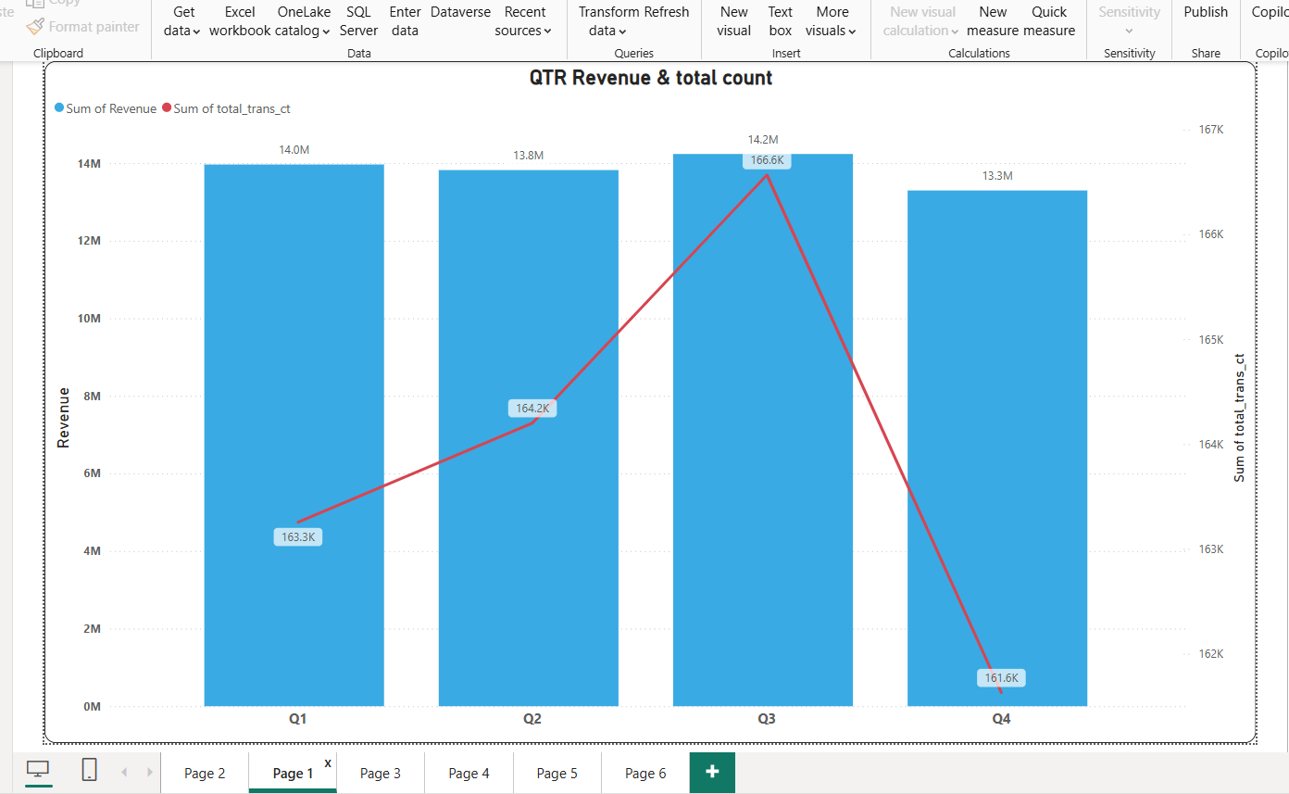

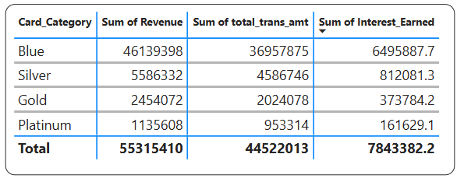

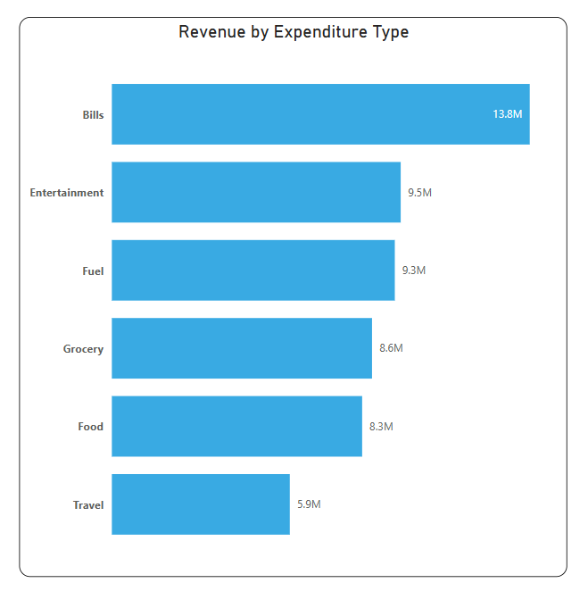

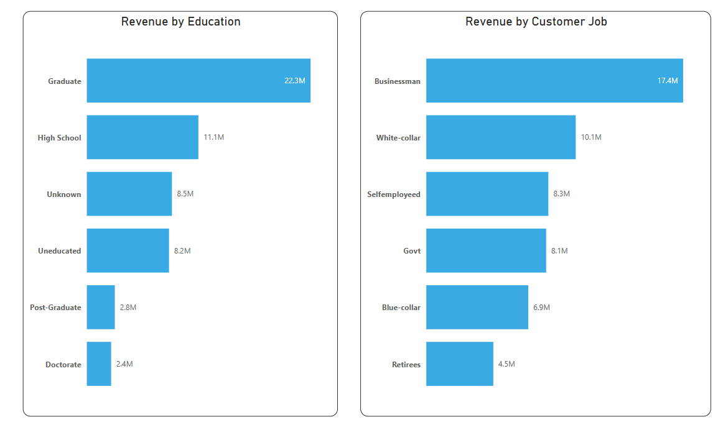

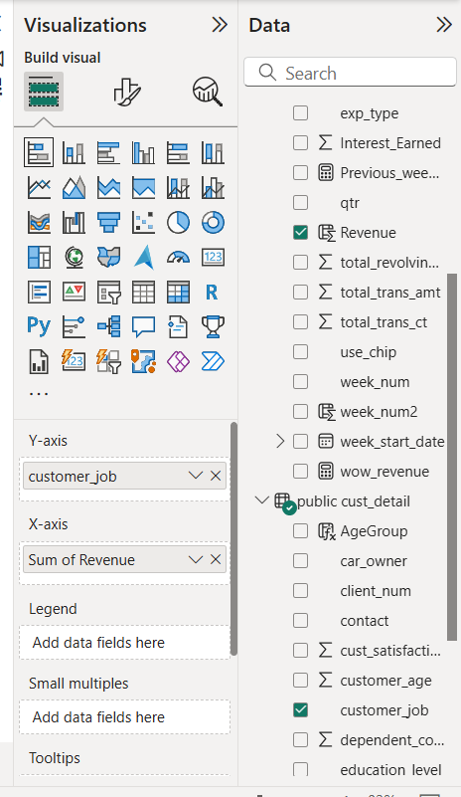

**BI 3**

**🔧 ETL Process in Power BI**

| **Step** | **Description** |
| --- | --- |
| ✅ Extract | Connect to data sources like Excel, SQL Server, Oracle, CSV, JSON, Web, etc. |
| 🔄 Transform | Clean, shape, and manipulate the data using **Power Query Editor**. |
| 📥 Load | Load the transformed data into the **Power BI Data Model** for visualization. |

**✅ Step 1: Extract – Connecting to Data Sources**

1. Open **Power BI Desktop**.
2. Go to **Home > Get Data**.
3. Choose your data source (e.g.):
   * **Excel** – select .xlsx file
   * **CSV** – select .csv file
   * **SQL Server** – enter server and database name
   * **Oracle** – provide connection details
4. Click **Connect**, preview the data, and load or transform it.

**🔄 Step 2: Transform – Clean and Shape the Data**

After clicking **Transform Data**, Power BI opens the **Power Query Editor**, where you can:

* **Rename columns**
* **Remove duplicates**
* **Filter rows**
* **Replace missing/null values**
* **Merge or append tables**
* **Create calculated columns**
* **Change data types**

Example actions in Power Query:

* Remove blank rows
* Change salary from text to decimal
* Extract year from JoiningDate
* Create new column: AnnualSalary = Salary * 12

Each transformation is recorded as a **step** in Power Query, so it’s **repeatable and automatic**.

**📥 Step 3: Load – Load Transformed Data into Power BI**

1. Once transformation is done, click **Close & Apply**.
2. The data is loaded into the **Power BI Data Model**.
3. You can now:
   * Create **data relationships**
   * Build **visualizations (charts, tables, maps, etc.)**
   * Use **DAX** to create calculated measures (e.g., TotalSalary = SUM(Salary))

**BI 5**

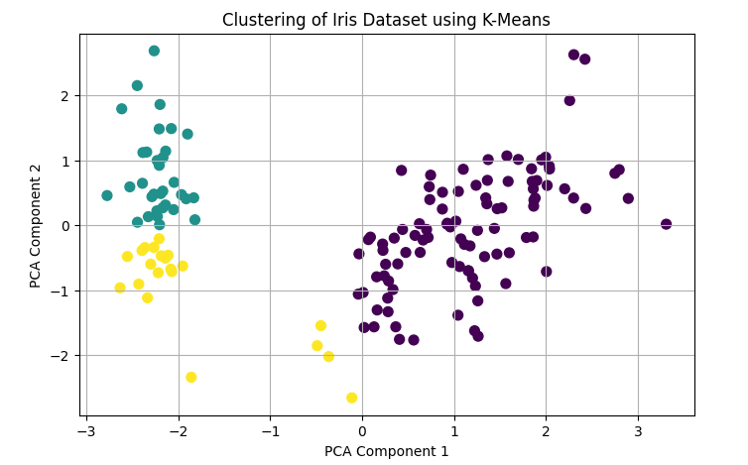

**BI 6**

